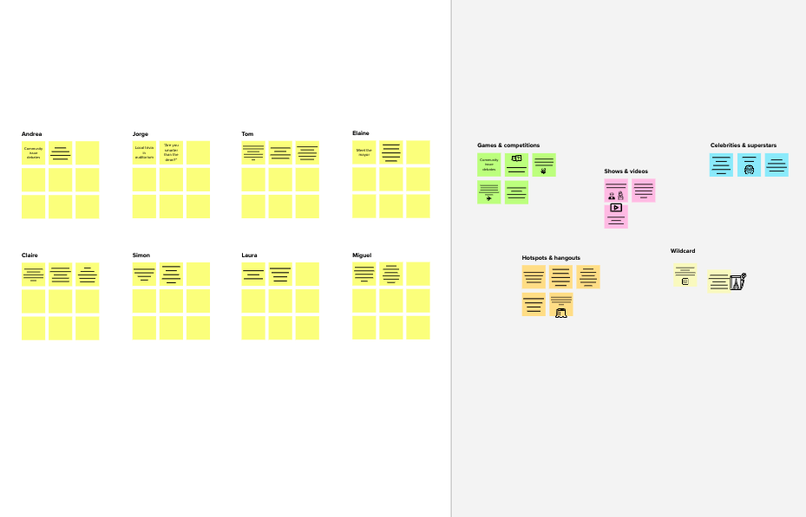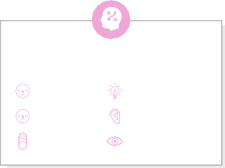

**1**

**Template**

# Define your problem statement

**Before you collaborate**

A little bit of preparation goes a long way with this session. Here’s what you need to do to get going.

**10 minutes**

What problem are you trying to solve? Frame your problem as a How Might We statement. This will be the focus of your brainstorm.

**5 minutes**

**2**

# Brainstorm

Write down any ideas that come to mind that address your problem statement.

**10 minutes**

**4**

# Prioritize

**3**

**Group ideas**

Take turns sharing your ideas while clustering similar or related notes as you go. Once all sticky notes have been grouped, give each cluster a sentence-like label. If a cluster is bigger than six sticky notes, try and see if you and break it up into smaller sub-groups.

**20 minutes**

Your team should all be on the same page about what's important moving forward. Place your ideas on this grid to determine which ideas are important and which are feasible.

**20 minutes**

# After you collaborate

You can export the mural as an image or pdf to share with members of your company who might find it helpful.

## Quick add-ons

**Brainstorm**

**& idea prioritization**

Use this template in your own brainstorming sessions so your team can unleash their imagination and start shaping concepts even if you're not sitting in the same room.

**PROBLEM**

**How might we prevent the forest fire by early detecting**

**methods?**

**TIP**

You can select a sticky note and hit the pencil [switch to sketch] icon to start drawing!

**NASEEHA JAFFAR ALI KALAIYARASI M**

**A Team gathering**

Define who should participate in the session and send an invite. Share relevant information or pre-work ahead.

A UAV can detect forest fire due to high mobility in vehicles

IR sensors can be used to detect to the forest fire

Collecting data using satellite image

Detecting fire using movement of Birds

**B Set the goal**

Think about the problem you'll be focusing on solving in the brainstorming session.

## USING TEMPERATURE

Detect the forest fire using CO2

Detect the forest fires by temperature regularly monitoring

Detecting the fire light and smoke plumes emitted from the fire

1. **Share the mural**

**Share a view link** to the mural with stakeholders to keep them in the loop about the outcomes of the session.

**TIP**

Add customizable tags to sticky notes to make it easier to find, browse, organize, and categorize important ideas as themes within your mural.

Forest officer can view the recommanable forest fire through SMS

Deep learning based Mathematical for detecting forest fire

1. **Export the mural**

Export a copy of the mural as a PNG or PDF to attach to emails, include in slides, or save in your drive.

**C Learn how to use the facilitation tools**

Use the Facilitation Superpowers to run a happy and productive session.

[**Open article**](https://support.mural.co/en/articles/2113740-facilitation-superpowers)

Collecting data using drones flying over the forest

**10 minutes** to prepare

**1 hour** to collaborate

**2-8 people** recommended

## Key rules of brainstorming

To run an smooth and productive session

Forest officer can view the recommanadable forest fire through SMS

Deep learning based Mathematical for detecting forest fires

Detecting by the fire light and smoke plumes emitted from the fires

Monitoring the forest using satellite

## USING VISUALS

**Keep moving forward**

**Strategy blueprint**

Detect the forest fires by temperature regularly monitoring

Collecting data using satellite image

Define the components of a new idea or strategy.

[**Open the template**](https://app.mural.co/template/e95f612a-f72a-4772-bc48-545aaa04e0c9/984865a6-0a96-4472-a48d-47639307b3ca)

Detecting fire using Movement of birds

**Customer experience journey map**

Stay in topic. Defer judgment.

Encourage wild ideas. Listen to others.

## Importance

Collecting data using drones flying over the forest

Detecting fire using movements of Birds

If each of these

Understand customer needs, motivations, and obstacles for an experience.

[**Open the template**](https://app.mural.co/template/b7114010-3a67-4d63-a51d-6f2cedc9633f/c1b465ab-57af-4624-8faf-ebb312edc0eb)

Detects the forest fires using CO2

Go for volume. If possible, be visual.

# MAHALAKSHMI R

**KANIMOZHI V**

tasks could get

done without any difficulty or cost, which would have the most positive impact?

**Strengths, weaknesses, opportunities & threats**

Identify strengths, weaknesses, opportunities, and threats (SWOT) to develop a plan.

|  |  |
| --- | --- |
|  |  |
|  |  |

[**Open the template**](https://app.mural.co/template/6a062671-89ee-4b76-9409-2603d8b098be/ca270343-1d54-4952-9d8c-fbc303ffd0f2)

Detecting the fire light and smoke plumes emitted from the fires

## USING METHODS

Fire detection using CNN modes

Detect the forest fire using CO2

Regularly remover dry leaves

Optical sensor and Digital cameras can be used

[**Share template feedback**](https://muralco.typeform.com/to/CiqaHVat?typeform-source=app.mural.co)

**TIP**

Detect the forest fires by temperatures regularly monitoring

Collecting data using drones flying over the forest

Fire fighting robots can now use sensors such as flame sensor to detect fires

Pre-trained model image processing

Participants can use their cursors to point at where sticky notes should go on the grid. The facilitator can confirm the spot by using the laser pointer holding the

**key** on the keyboard.

**H**

Forest officer can view the recommanable forest fire through SMS

Deep learning based Mathematical for detecting forest fires

Collecting data using satellite image

## Feasibility

[**Share template feedback**](https://muralco.typeform.com/to/CiqaHVat?typeform-source=app.mural.co)

Regardless of their importance, which tasks are more feasible than others? (Cost, time, effort, complexity, etc.)

**Need some inspiration?**

See a finished version of this template to kickstart your work.

[**Open example**](https://app.mural.co/template/e5a93b7b-49f2-48c9-afd7-a635d860eba6/93f1b98d-b2d2-4695-8e85-7e9c0d2fd9b9)